PIZZA SALES ANALYSIS
For KPI’s
- Total Revenue
select sum(total_price) AS Total_Revenue from pizza_sales;
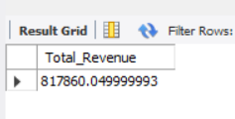
- Average Order Value
select sum(total_price) / count (distinct order_id) AS Average_Order_value from pizza_sales;
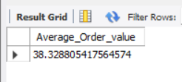
- Total Pizza Sold
select sum(quantity) AS Total_Pizza_Sold from pizza_sales;
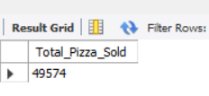
- TOTAL ORDERS
select count(distinct order_id) AS Total_Orders from pizza_sales;
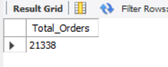

- AVERAGE PIZZAS PER ORDER
select sum(quantity) / count(distinct order_id)
AS Average_Pizza_Per_Order
from pizza_sales;
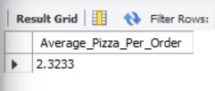

CHARTS REQUIREMENTS

- DAILY TRENDS FOR ORDERS

SELECT DAYNAME(order_date) AS order_day,
COUNT(DISTINCT order_id) AS Total_orders
FROM pizza_sales
GROUP BY DAYOFWEEK(order_date), DAYNAME(order_date)
ORDER BY DAYOFWEEK(order_date);
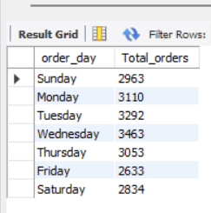

- MONTHLY TRENDS FOR ORDERS
SELECT monthname(order_date) AS Month_Name,
count(distinct order_id) AS Total_Orders
from pizza_sales
GROUP BY monthname(order_date)
ORDER BY Total_Orders desc;
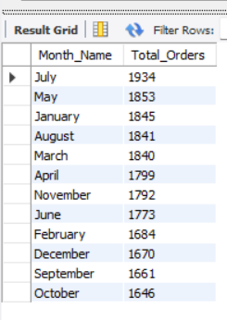

- PERCENTAGE OF PIZZA SALES BY CATEGORY
select pizza_category, sum(total_price) * 100 / (select sum(total_price) from pizza_sales) AS PCT_Total_Sales
from pizza_sales
GROUP BY pizza_category;
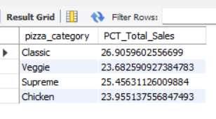

- PERCENTAGE OF PIZZA SALES BY SIZE
select pizza_size,CAST(sum(total_price) AS DECIMAL(10,2)) AS total_revenue ,
cast(sum(total_price) * 100 / (select sum(total_price) from pizza_sales) AS DECIMAL(10,2))AS PCT
from pizza_sales
GROUP BY pizza_size
ORDER BY pizza_size;

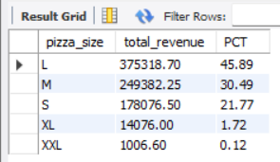

- TOP 5 PIZZAS BY REVENUE

SELECT pizza_name, sum(total_price) AS Total_Revenue
from pizza_sales
GROUP BY pizza_name
ORDER BY Total_Revenue desc
LIMIT 5;

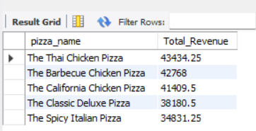

- BOTTOM 5 PIZZAS BY REVENUE

SELECT pizza_name, sum(total_price) AS Total_Revenue
from pizza_sales
GROUP BY pizza_name
ORDER BY Total_Revenue
LIMIT 5;
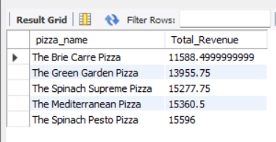

- TOP 5 PIZZAS BY QUANTITY
SELECT pizza_name, sum(quantity) AS Total_Quantity
from pizza_sales
GROUP BY pizza_name
ORDER BY Total_Quantity DESC
LIMIT 5;

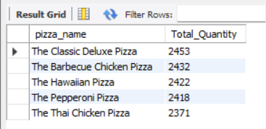

- BOTTOM 5 PIZZAS BY QUANTITY
SELECT pizza_name, sum(quantity) AS Total_Quantity
from pizza_sales
GROUP BY pizza_name
ORDER BY Total_Quantity
LIMIT 5;

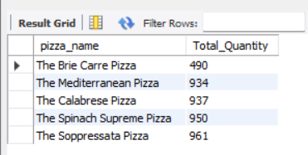

- TOP 5 PIZZAS BY ORDERS
SELECT pizza_name, COUNT(DISTINCT order_id) AS Total_Orders
from pizza_sales
GROUP BY pizza_name
ORDER BY Total_Orders DESC
LIMIT 5;

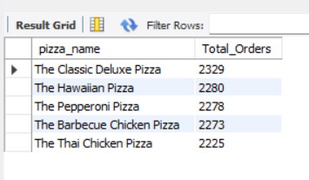

- BOTTOM 5 PIZZAS BY ORDERS
SELECT pizza_name, COUNT(DISTINCT order_id) AS Total_Orders
from pizza_sales
GROUP BY pizza_name
ORDER BY Total_Orders
LIMIT 5;

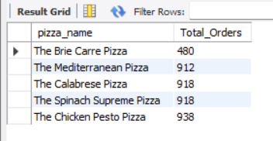

- Top Pizzas By Rank
SELECT
pizza_name,
SUM(total_price) AS Revenue,
RANK() OVER (ORDER BY SUM(total_price) DESC) AS Revenue_Rank
FROM pizza_sales
GROUP BY pizza_name;

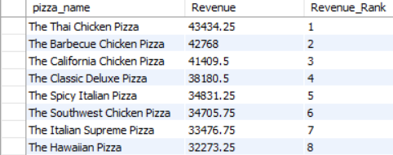

- Revenue Category according to Revenue
select
pizza_name,
SUM(total_price) AS Revenue,
CASE
WHEN SUM(total_price) > 40000 THEN 'High Revenue'
WHEN SUM(total_price) > 20000 THEN 'Medium Revenue'
ELSE 'Low Revenue'
END AS Revenue_Category
FROM pizza_sales
GROUP BY pizza_name;
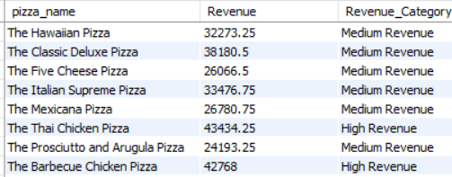

- Running Total
SELECT
order_date,
SUM(total_price) AS Daily_Revenue,
SUM(SUM(total_price))
OVER (ORDER BY order_date) AS Running_Revenue
FROM pizza_sales
GROUP BY order_date;
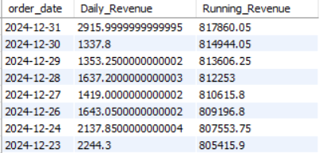

- Dense Rank
SELECT
pizza_category,
pizza_name,
SUM(total_price) AS Revenue,
DENSE_RANK() OVER (
PARTITION BY pizza_category
ORDER BY SUM(total_price) DESC
) AS Category_Rank
FROM pizza_sales
GROUP BY pizza_category, pizza_name;

